**REPORT ON AMES HOUSING DATASET VISUALISATION USING RSHINY**

DINESH CHAVALI

ALY-6070: COMMUNICATE/VISUAL DATA ANALYSIS

CPS-2020 WINTER QUARTER



INSTRUCTOR – MR. JUSTIN GROSZ

ASSIGNMENT DATE- 06 FEB 2020

**Abstract:**

The [Ames Housing dataset](http://www.amstat.org/publications/jse/v19n3/decock.pdf) was compiled by Dean De Cock for use in data science education. It's an incredible alternative for data scientists looking for a modernized and expanded version of the often cited Boston Housing dataset. The data set has 79 explanatory variables describing every aspect of residential homes in Ames ,Iowa.

The current work on visualization primarily built on analyzing variables like Sales Price, Year Built, Year RemodAdd( year of remodeling), Neighborhood and also relation between the house price and the connecting road being an Artery or Normal road and locating the top 5 highest average sales price locations in Ames

**Visualization:**

The visualization is aimed at answering questions on

1. Understanding the sales price distribution across Ames
2. Relation between the age of the building and the sales price
3. A reactive plot that takes input from the side panel and gives respective neighborhood’s sales price distribution
4. Box plot showing the 5 value summary for the sales price for normal road and artery road
5. Geo map of top 5 high average sales price recorded in Ames

It could be seen from the sales price distribution that around $ 1,50,000 is the sales price that has the most frequency. The linear regression plot between Sales Price and Age clearly shows a negative relationship. The Box plot shows that the houses which connect to normal roads have higher median sales price.

**Sales price distribution in Ames**

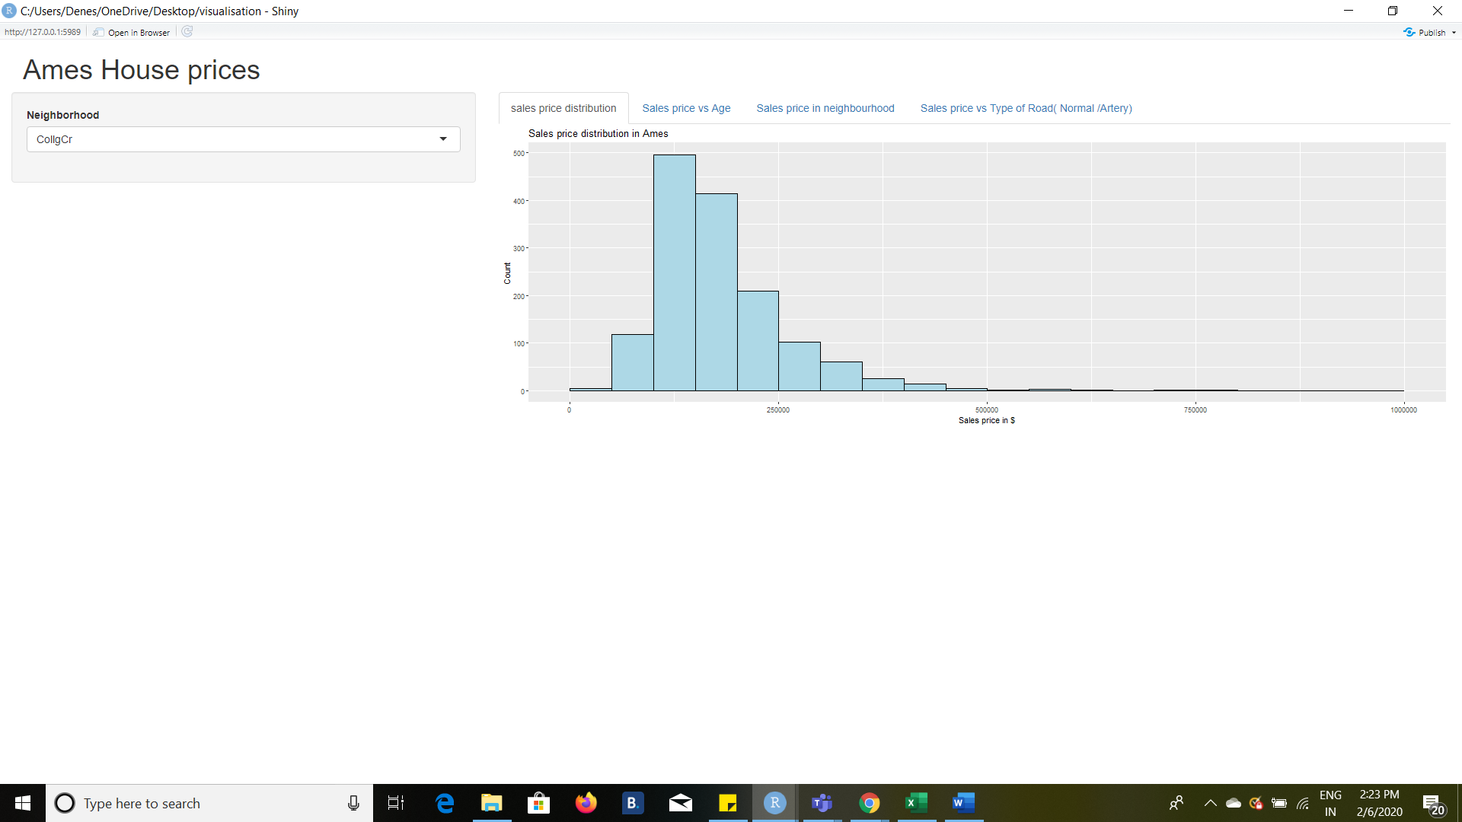

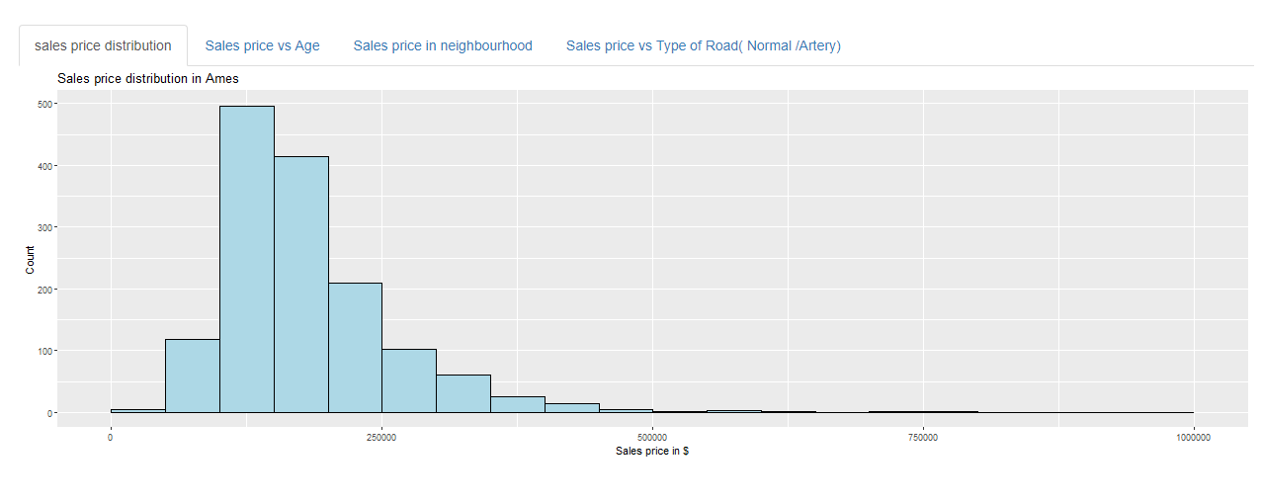

**Regression between sales price and Age of the building**

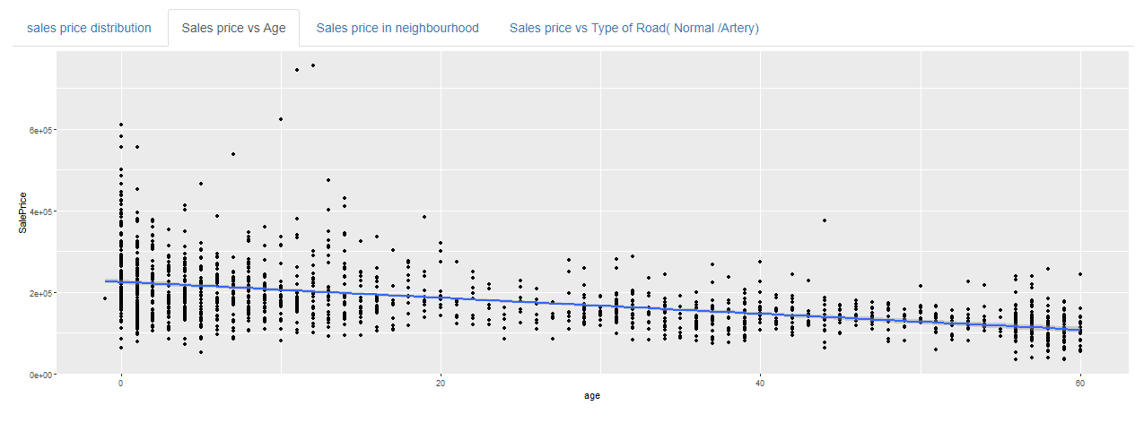 **Sales price distribution for Somerset ,Ames**

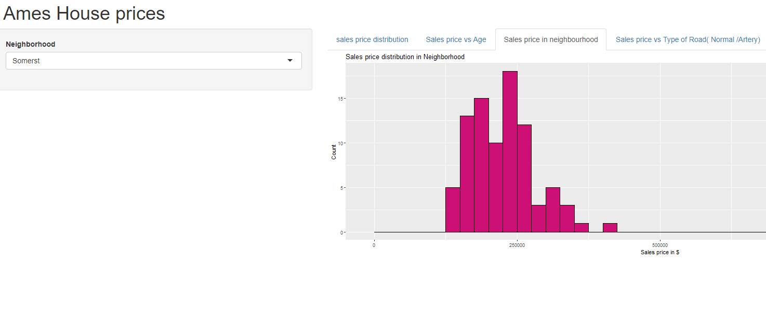

**Sales price distribution in Timber East, Ames**

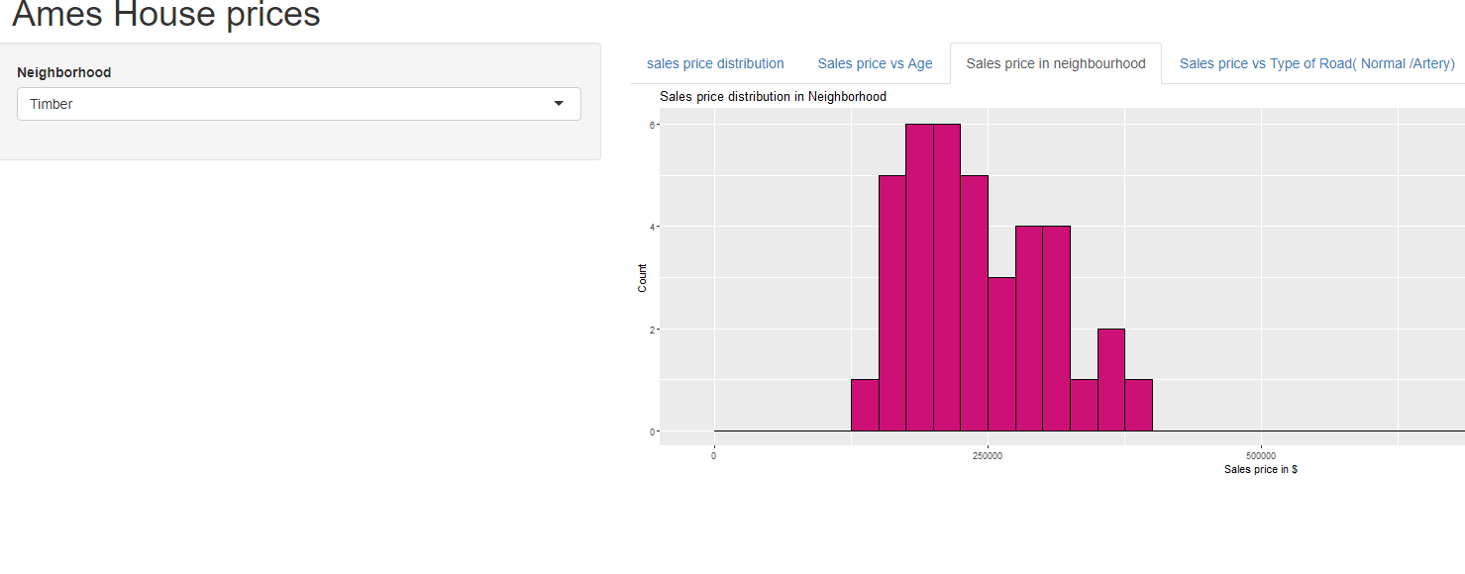

Box plot for houses with normal road vs artery road connection

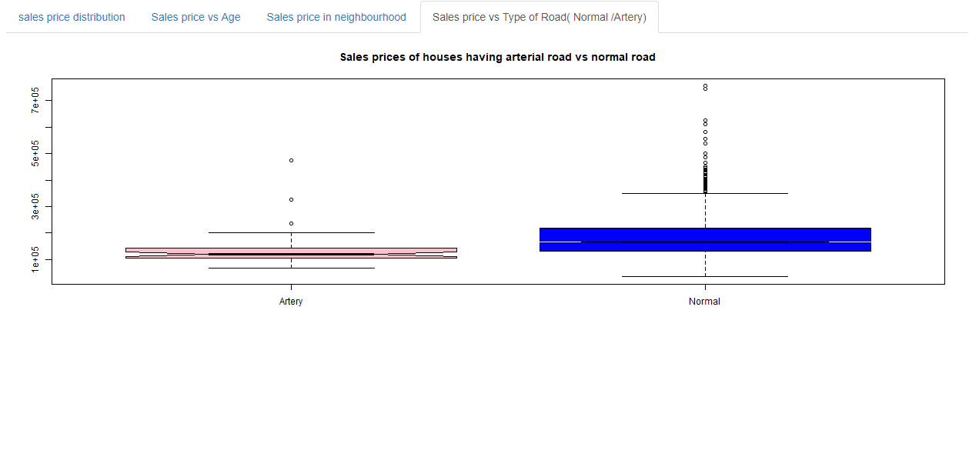

**Geo Plot showing the top 5 average sales price values**

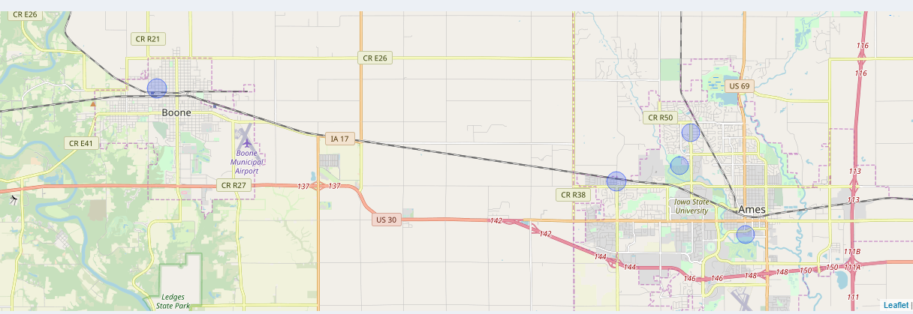

**References:**

* <https://www.kaggle.com/c/house-prices-advanced-regression-techniques/overview/description>
* <https://gps-coordinates.org/united-states-latitude.php>
* <https://deanattali.com/blog/building-shiny-apps-tutorial/#1-before-we-begin>
* Datacamp/starwars